November 28, 2017

University of Sussex

Student Number:184521

Action On Weight Program Student Number:184521

Contents

Pseudo Code 3

Write Program 3

Read Program 5

Screen Design 6

Write Program 6

Log In Screen 6

Options Screen 6

Add Screen 6

Read Program 7

File Name Screen 7

Patient View Screen 7

View Another Student Screen 8

Validations 9

Flowchart 10

Write Program 10

Read Program 10

JSP Diagram 11

Write Program 11

Read Program 11

Program Code 12

Write Program 12

Read Program 20

Screenshots 30

Write Program 30

Log In Screen 30

Options Screen 30

Add Screen 30

Read Program 31

File Name Screen 31

Patient View Screen 31

Add Comment Screen 31

View Another Student Screen 31

Testing 32

Write Program-Test Plan 32

Write Program-Test Log 32

Read Program-Test Plan 35

Read Program-Test Log 36

Evaluation 41

# Pseudo Code

## Write Program

Enter ID Function

Enter ID

Open logIn file

Check for ID

If ID correct

Enter password Function

Not correct

Print Incorrect

Enter ID Function

Enter Password Function

Enter Password

Shift by 7

Open logIn file

Check for Password

If password correct

Edit or Add Function

Not correct

Print Incorrect

Enter Password Function

Add or Exit Function

Add or exit?

If Add

Add function

If exit

Exit function

Add Function

File Name

Open file name in write mode

Name

Date of Birth

Height

Waist Measurement

Weight

Comments

Exit or Add Function

Exit Function

Exit

## Read Program

FileName Function

Input Surname

Input D.O.B

filename=surname+D.O.B

PatientView Function

PatientView Function

Open File Name

Print file

Do you wish to add comments

If yes

Open file in write append

Continue Function

Continue function

Would you to like to view another patient

If yes

File name function

If no

Exit function

Exit Function

Exit

# Screen Design

## Write Program

### Log In Screen

A simple screen that takes the user’s ID and password to be compared against the log in file and shall be used by the first program to sign in.

----------------------------------------------------

What is your ID?

>>>

----------------------------------------------------

What is your Password?

>>>

----------------------------------------------------x

### Options Screen

This screen allows the user to choose which function of the write program they want to use by typing edit, add or exit.

----------------------------------------------------

Do you wish to add or exit?

>>>

----------------------------------------------------

What is your Password?

>>>

----------------------------------------------------x

### Add Screen

----------------------------------------------------

What is name of the patient?

>>>

What is their D.O.B? (dd/mm/yy)

>>>

What is their height?

>>>

What is their waist measurement?

>>>

What is their weight?

>>>

Any Comments?

>>>

----------------------------------------------------

This screen allows the user to enter the details of the patient with ease due to its simplistic layout.

## Read Program

### File Name Screen

This screen takes the surname of the patient and their date of birth and uses them to construct the file name that shall be used for the file that shall be read from. As the address for the file is the surname plus their birth date with the file extension aow.

===============================

What is surname of the patient?

>>>

----------------------------------------------------

What is their D.O.B? (dd/mm/yy)

>>>

===============================

### Patient View Screen

This screen shows all of the patient’s information and allows the user to choose whether they want to add new comments to the patients profile. If no comments are added, then it shall display N/A.

----------------------------------------------------

Patient’s First Name: Kingsley

Patient’s Surname: Sage

D.O.B (dd/mm/yy): 030299

Height:3m

Weight:10lbs

Waist Measurement:36cm

Comments: N/A

----------------------------------------------------

Do you wish to add comments?

>>>Yes

----------------------------------------------------

New Comments

>>>

----------------------------------------------------

### View Another Student Screen

This screen follows the previous and asks the user if they wish to view another student. If they say yes it will ask for the surname and date of birth of the next patient. This will allow the user to view the previous screen but with new information present. If the user selects no the program shall exit.

----------------------------------------------------

Do you wish to view another student?

>>>Yes

----------------------------------------------------

What is surname of the patient?

>>>

What is their D.O.B? (dd/mm/yy)

>>>

----------------------------------------------------

## Validations

The following screen designs are mock-ups for certain validations throughout the program

----------------------------------------------------

What is your ID?

>>>Thereas yaM

----------------------------------------------------

What is your Password?

>>>xf2g3d2

----------------------------------------------------

Username or Password is Incorrect

Do you wish to try again?

>>>

----------------------------------------------------

What is surname of the patient?

>>>kingslye

What is their D.O.B? (dd/mm/yy)

>>>300299

----------------------------------------------------

!File Doesn’t Exist!

----------------------------------------------------

Do you wish to try again?

>>>

----------------------------------------------------

----------------------------------------------------

Do you wish to view another student?

>>>seY

----------------------------------------------------

Unrecognised Input

Please try Again

----------------------------------------------------

What is your Password?

>>>

----------------------------------------------------x

----------------------------------------------------

Do you wish to add another student?

>>>dasda

----------------------------------------------------

Unrecognised Input

Please try Again

----------------------------------------------------

What is your Password?

>>>

----------------------------------------------------x

----------------------------------------------------

Do you wish to add or exit?

>>>eixt

----------------------------------------------------

Unrecognised Input

Please try Again

----------------------------------------------------

What is your Password?

>>>

----------------------------------------------------x

----------------------------------------------------

Do you wish to view another student?

>>>oN

----------------------------------------------------

Unrecognised Input

Please try Again

----------------------------------------------------

What is your Password?

>>>

----------------------------------------------------x

# Flowchart

## Write Program

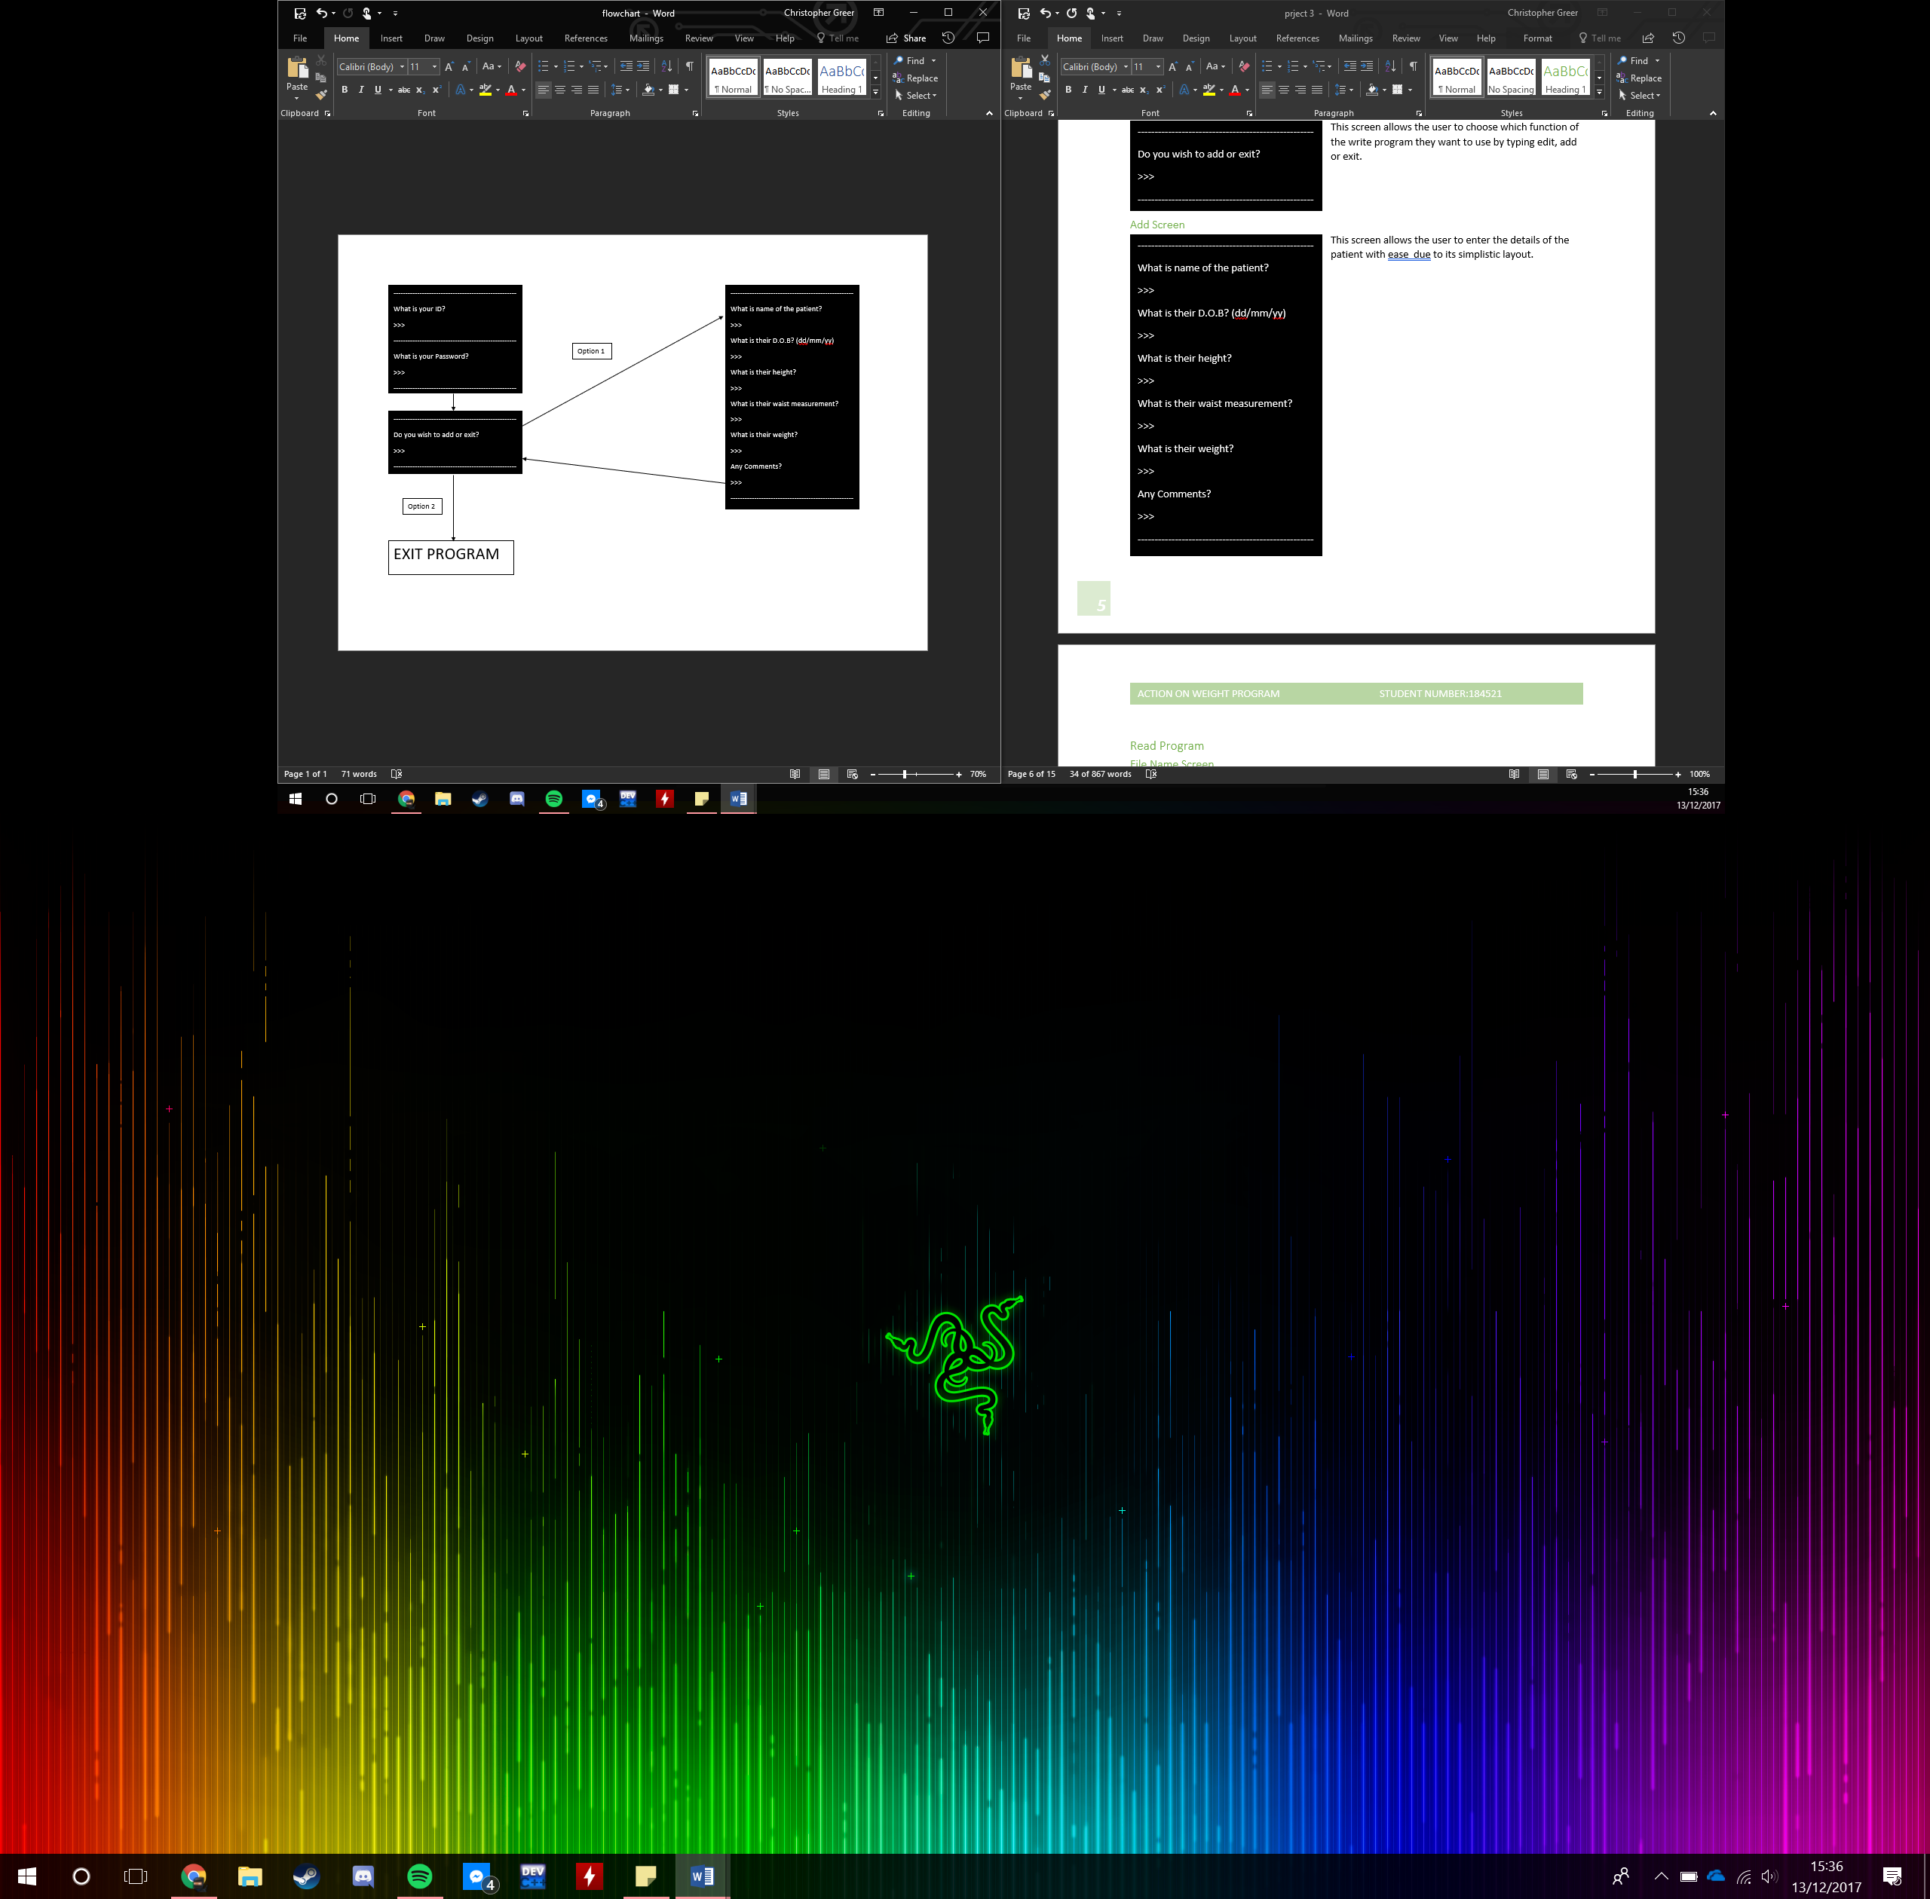

## Read Program

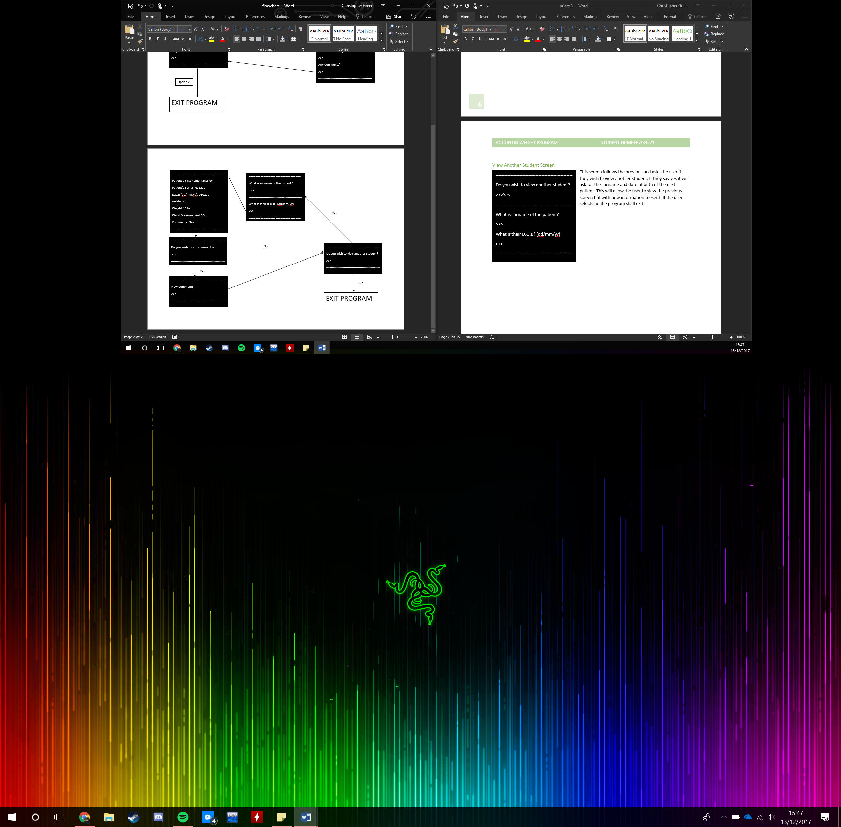

# JSP Diagram

## Write Program

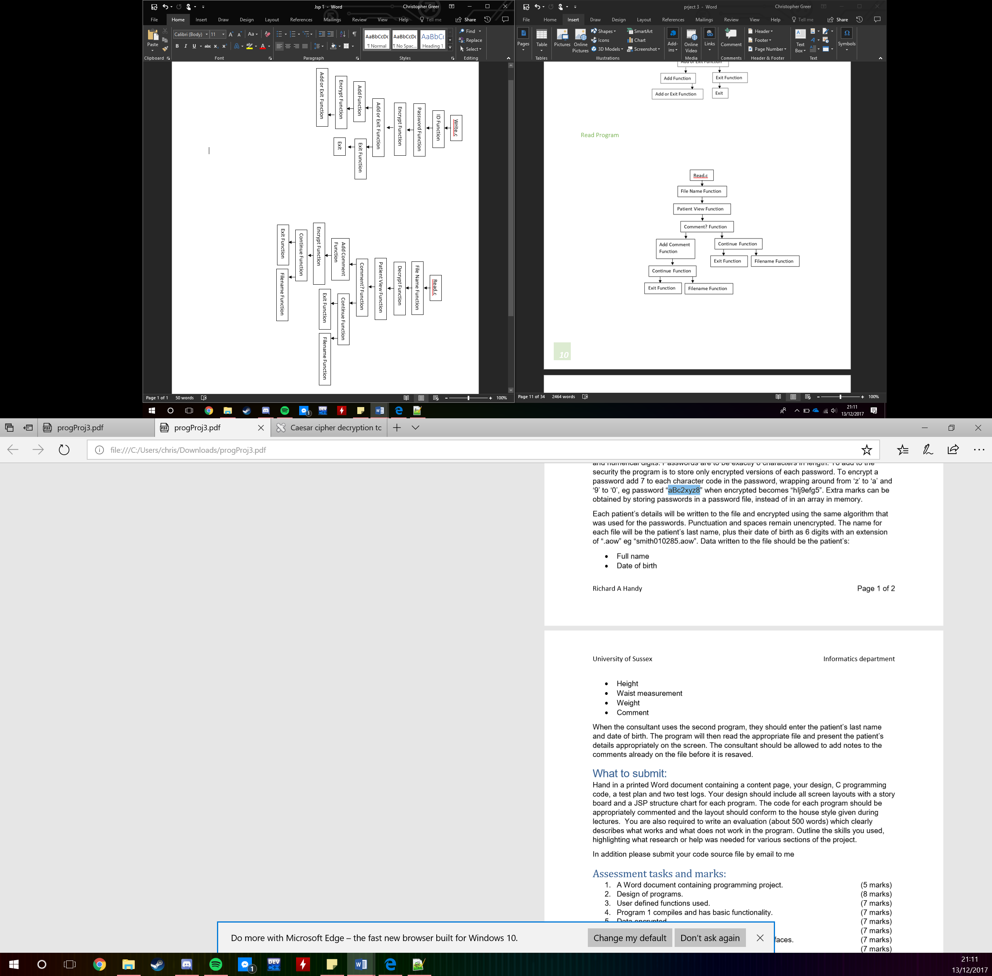

## Read Program

# Program Code

## Write Program

/***********************************************************************

* WriteProgram.c

* Allows one of the nurses to enter patient details

* into a computer file

* Christopher Greer

* 28th November 2017

/***********************************************************************/

#include <stdio.h>

#include <string.h>

#include <stdlib.h>

FILE*fp;

void enterName(void);

void enterPassword(char filename[30]);

void Options(void);

void Add(char surname[8],char dob[8],char fN[20]);

void fileName(void);

char encrypt(char toBe[100]);

void exitFunc();

//This function takes the first name of the nurse and creates

//their file name and uses it to check if they exist

void enterName(void)

{

char name[30],opt[1],filename[30];

printf("=========================================================");

printf("\nWhat is your first name?\n");

printf(">>>");

scanf("%s[^' ']",&name);

printf("---------------------------------------------------------");

sprintf(filename, "%s.aow", name);

fp=fopen(filename,"r");

if (fp != NULL)

{

enterPassword(filename);

}

else

{

printf("\nWrong Username, Please Try Again\n");

enterName();

}

}

//This file takes the users password and checks it in their file

void enterPassword(char filename[30])

{

char password[8],chr,fPassword[8],toBe[8];

printf("\nWhat is your password?\n");

printf(">>>");

scanf("%s",&password);

fp=fopen(filename,"r");

encrypt(password);

fgets(fPassword,9,fp)!=NULL;

if (strcmp(fPassword,password)==0)

{

fclose(fp);

Options();

}

else

{

fclose(fp);

printf("=========================================================");

printf("\n !Password is Incorrect!\n");

enterName();

}

}

//This fuction is the main menu of the program

void Options(void)

{

int option;

printf("=========================================================");

printf("\n Main Menu\n");

printf("---------------------------------------------------------");

printf("\nWhat function do you wish to use?\n");

printf("Option 1:Add\n");

printf("Option 2:Exit\n");

printf("---------------------------------------------------------");

printf("\n>>>");

scanf("%d",&option);

printf("=========================================================");

switch(option)

{

case 1:

fileName();

break;

case 2:

exitFunc();

break;

default:

printf("\n !Incorrect Option!\n");

Options();

}

}

//This function encrypts anything that is given to it

char encrypt(char toBe[100])

{

char chr;

int i, key;

key=7;

for(i=0;toBe[i] !='\0'; ++i)

{

chr=toBe[i];

if(chr >='a'&& chr<='l')

{

chr=chr+key;

}

else if(chr >='m'&& chr<='s')

{

chr=chr-76;

}

if(chr >='t'&& chr<='z')

{

chr=chr-68;

}

else if(chr>='A' && chr<='S')

{

chr=chr+key;

}

else if(chr>='T' && chr<='Z')

{

chr=chr+13;

}

else if(chr>='0' && chr<='2')

{

chr=chr+key;

}

else if(chr>='3' && chr<='9')

{

chr=chr+14;

}

toBe[i]=chr;

}

}

//This function takes the users entries and adds them to

//a patient's file

void Add(char surname[8],char dob[8],char fN[20])

{

char name[50],height[50],waist[50],weight[50],comment[1000]

, surnamef[50],commentf[250],dobf[50], heightf[50],

waistf[50],weightf[50];

fp=fopen(fN,"w");

printf("\nWhat is the first name of the patient?");

printf("\n>>>");

scanf("%s",&name);

encrypt(name);

fprintf(fp,"%s ",name);

encrypt(surname);

fprintf(fp, "%s", surname);

sprintf(dobf, "\n Date of Birth: %s", dob);

encrypt(dobf);

fprintf(fp,"%s", dobf);

printf("\nWhat is the Height of the patient in metres?");

printf("\n>>>");

scanf("%s",&height);

getchar();

sprintf(heightf,"\nHeight: %sm",height);

encrypt(heightf);

fprintf(fp,"%s",heightf);

printf("\nWhat is the Waist Measurement of the patient");

printf("in Inches?");

printf("\n>>>");

scanf("%[^\n]",&waist);

getchar();

sprintf(waistf,"\nWaist Measurement:%s Inches",waist);

encrypt(waistf);

fprintf(fp,"%s",waistf);

printf("\nWhat is the Weight of the patient in Kg?");

printf("\n>>>");

scanf("%[^\n]",&weight);

getchar();

sprintf(weightf,"\n Weight:%skg",weight);

encrypt(weightf);

fprintf(fp,"%s",weightf);

printf("\nAre there any comments for the patient?");

printf("\nIf not type N/A");

printf("\n>>>");

scanf("%[^\n]",&comment);

getchar();

sprintf(commentf,"\nComments:%s",&comment);

encrypt(commentf);

fprintf(fp,"%s",commentf);

fclose(fp);

Options();

}

//This function creates the file name for the patient file

void fileName(void)

{

char fN[20],surname[8], dob[8];

printf("\nWhat is the surname of the patient?");

printf("\n>>>");

scanf("%s",&surname);

getchar();

printf("\nWhat is the Date of Birth of the patient?");

printf("\n>>>");

scanf("%s",&dob);

getchar();

sprintf(fN,"%s%s.aow",surname, dob);

Add(surname,dob,fN);

}

//This function is called when the prgram needs to be exited

void exitFunc(void)

{

exit(0);

}

//This is the main function of the program and is the first to be called

int main(void)

{

printf("=========================================================");

printf("\n Welcome to Patient Entry\n");

enterName();

return 0;

}

## Read Program

/***********************************************************************

* ReadProgram.c

* Allows theconsultant to read the computer file generated

* by the previous program

* Christopher Greer

* 28th November 2017

/**********************************************************************/

#include <stdio.h>

#include <stdlib.h>

FILE* fp;

void fileName(void);

void patientView(char fN[20]);

char encrypt(char toBe[100]);

char decrypt(char notToBe[1000]);

void cont(void);

void comment(char fN[20]);

void addComment(char fN[20]);

void exitFunc(void);

//Takes the patients surname and date of birth and uses them

//to get the file name for that patient

void fileName(void)

{

char surname,fN[20],dob[20];

printf("=========================================================");

printf("\n What is the surname of the patient you wish to view?");

printf("\n>>>");

scanf("%s",&surname);

printf("--------------------------------------------------------");

printf("\n What is the D.O.B of the patient you wish to view?");

printf("\n Enter in format ddmmyy (030299)");

printf("\n>>>");

scanf("%s",&dob);

sprintf(fN,"%s%s.aow",&surname, &dob);

printf("=========================================================");

patientView(fN);

}

//This function takes the filename and opens the file with that

//name and displays it to the user

void patientView(char fN[20])

{

char chr[10000];

fp=fopen(fN,"r");

if (!fp)

{

printf("\n !FILE NOT FOUND!\n");

printf("---------------------------------------------------------");

printf("\nPlease check input for capitalisation of surname\n");

printf("or the input of incorrect information\n");

printf("=========================================================");

printf("\nDo you wish to try again?");

printf("\nPlease use Y or N");

cont();

}

else

{

printf("\n File found\n");

printf("---------------------------------------------------------");

printf("\n");

while (fgets(chr,10000,fp)!=NULL)

{

decrypt(chr);

puts(chr);

}

printf("\n");

printf("=========================================================");

comment(fN);

}

}

//This function decrypts anything given to it

char decrypt(char notToBe[1000])

{

char chr;

int i, key;

key=7;

for(i=0;notToBe[i] !='\0'; ++i)

{

chr=notToBe[i];

if(chr >='a'&& chr<='g')

{

chr=chr-13;

}

else if(chr >='h'&& chr<='z')

{

chr=chr-key;

}

else if(chr>='A' && chr<='G')

{

chr=chr-14;

}

else if(chr>='H' && chr<='Z')

{

chr=chr-key;

}

else if(chr>='0' && chr<='6')

{

chr=chr+68;

}

else if(chr>='7' && chr<='9')

{

chr=chr-key;

}

else if(chr >='!'&& chr<=')')

{

chr=chr+76;

}

notToBe[i]=chr;

}

}

//This function encrypts what ever is given to it

char encrypt(char toBe[100])

{

char chr;

int i, key;

key=7;

for(i=0;toBe[i] !='\0'; ++i)

{

chr=toBe[i];

if(chr >='a'&& chr<='l')

{

chr=chr+key;

}

else if(chr >='m'&& chr<='s')

{

chr=chr-76;

}

if(chr >='t'&& chr<='z')

{

chr=chr-68;

}

else if(chr>='A' && chr<='S')

{

chr=chr+key;

}

else if(chr>='T' && chr<='Z')

{

chr=chr+13;

}

else if(chr>='0' && chr<='2')

{

chr=chr+key;

}

else if(chr>='3' && chr<='9')

{

chr=chr+14;

}

toBe[i]=chr;

}

}

//This function asks the user if they wish to continue, if they don't

//they shall then exit the program

void cont(void)

{

fp;

char opt[0];

printf("\n>>>");

scanf("%s",opt);

fclose(fp);

if (opt[0]=='y')

{

printf("=========================================================");

printf("\n\n\n\n\n\n\n\n\n\n\n\n\n\n\n\n\n\n\n\n\n\n\n\n\n\n\n\n");

fileName();

}

else if (opt[0]=='n')

{

printf("=========================================================");

printf("\n Exiting Program..............\n");

printf("=========================================================");

exitFunc();

}

else if (opt[0]=='Y')

{

printf("=========================================================");

printf("\n\n\n\n\n\n\n\n\n\n\n\n\n\n\n\n\n\n\n\n\n\n\n\n\n\n\n\n");

fileName();

}

else if (opt[0]=='N')

{

printf("=========================================================");

printf("\n Exiting Program..............\n");

printf("=========================================================");

exitFunc();

}

else

{

printf("Incorrect input try again");

cont();

}

}

//This function asks the user if they wish to comment

//if they do not then they rturn to the first function

void comment(char fN[20])

{

char opt[1];

printf("\nDo you wish to add comments?");

printf("\nPlease use Y or N");

printf("\n>>>");

scanf("%s",opt);

getchar();

if (opt[0]=='y')

{

addComment(fN);

}

else if (opt[0]=='n')

{

printf("=========================================================");

printf("\nDo you wish to view another patient?");

printf("\nPlease use Y or N");

cont();

}

else if (opt[0]=='Y')

{

addComment(fN);

}

else if (opt[0]=='N')

{

printf("=========================================================");

printf("\nDo you wish to view another patient?");

printf("\nPlease use Y or N");

cont();

}

else

{

printf("Incorrect input try again");

comment(fN);

}

}

//This function is used to add a comment to

void addComment(char fN[20])

{

char comt[1000];

printf("=========================================================");

printf("\n What comment would you wish to add?\n");

fp=fopen(fN,"a+");

printf(">>>");

scanf("%[^\n]",&comt);

getchar();

encrypt(comt);

fprintf(fp,"\n%s",comt);

printf("=========================================================");

printf("\nDo you wish to view another patient?");

printf("\nPlease use Y or N");

cont();

}

//This functions purpose is simply to exit the program

void exitFunc(void)

{

exit(0);

}

//This is the main fucntion of the program where the whole program

//starts by printing a welcome banner then calling filename()

int main(void)

{

char fN;

printf("=========================================================");

printf("\n Welcome to Patient View\n");

fileName();

return 0;

}

# Screenshots

The following screenshots are from the final versions of the program and display all of the given screens of the final program

## Write Program

### Log In Screen

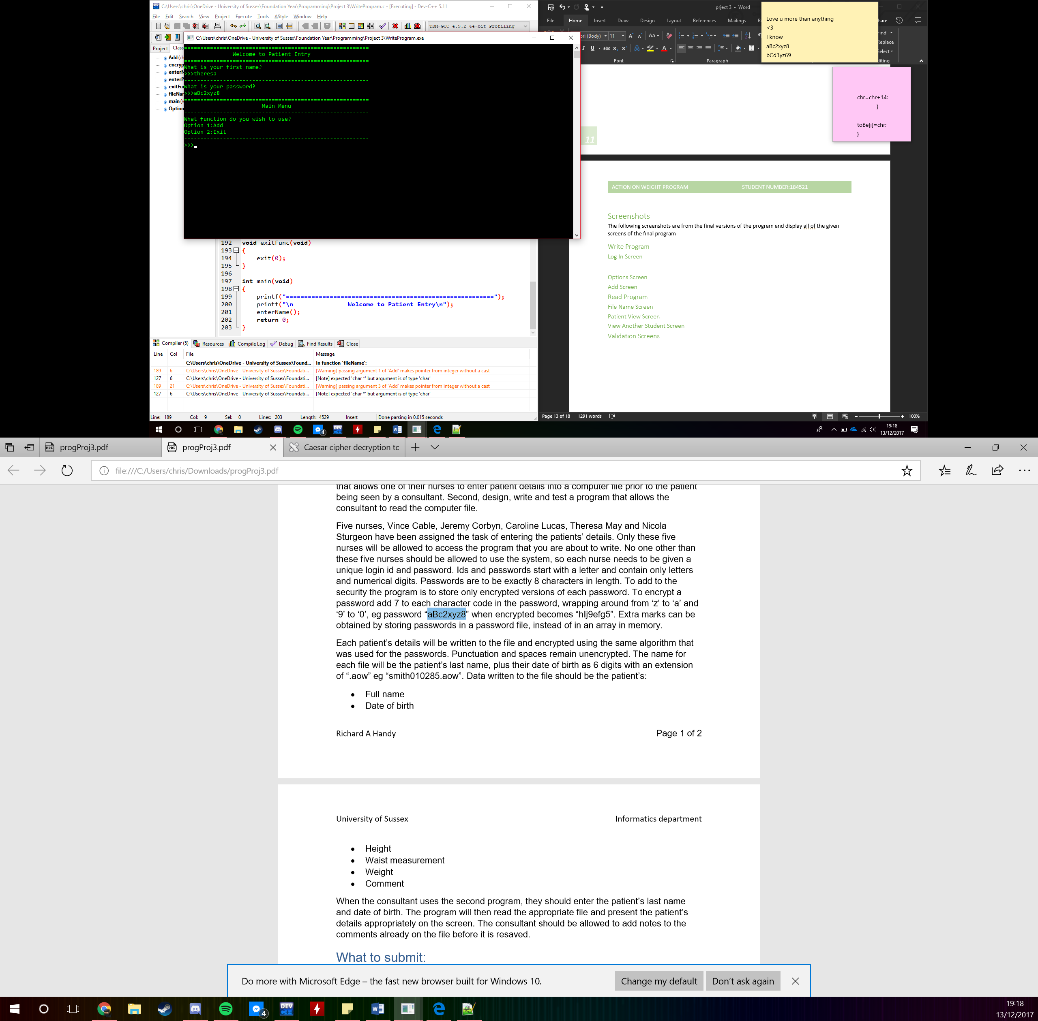The log in screen has stayed fundamentally the same other than the inputs becoming more separated and the inclusion of the welcome banner.

### Options Screen

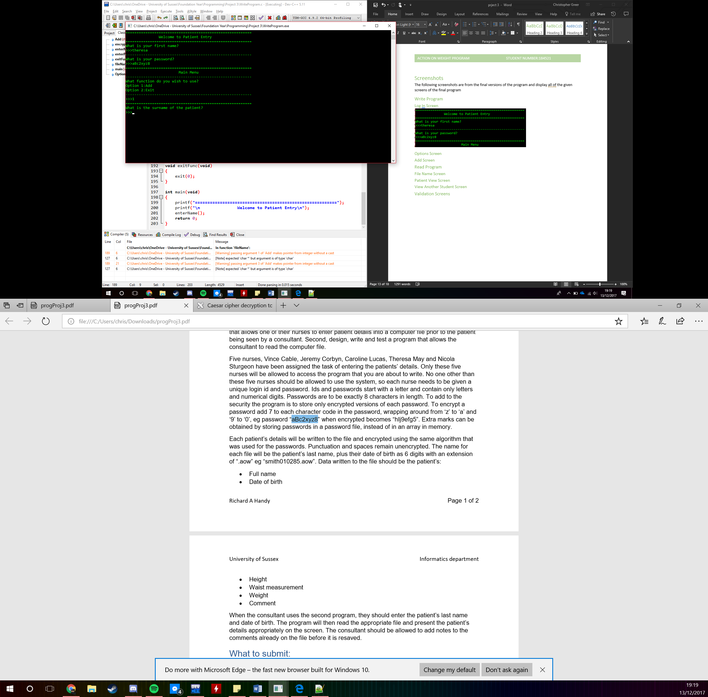The options screen has also changed since the design as it is no longer just on a single line with an input. Now it looks like a fully functional menu with options and a welcome banner.

### Add Screen

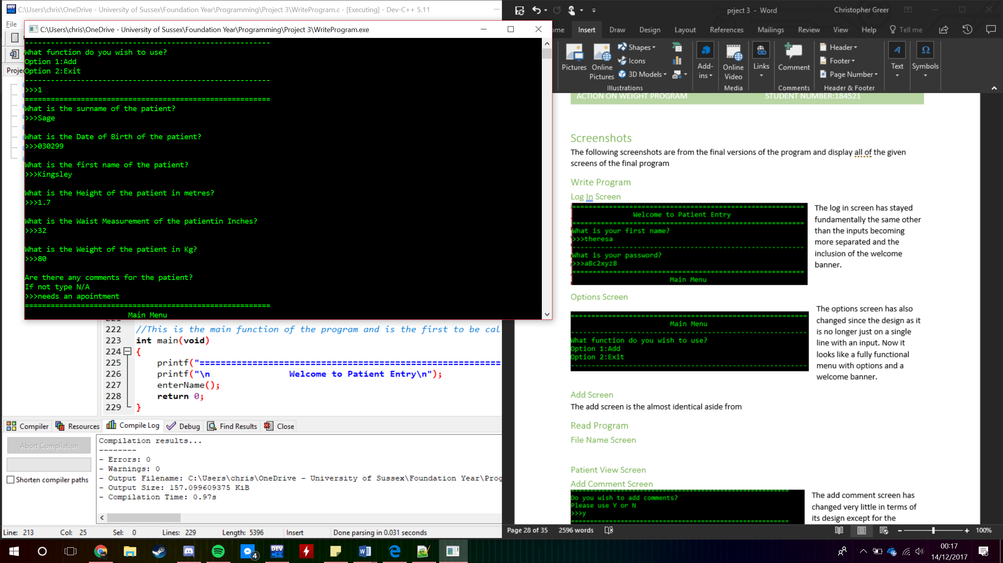The add screen is almost identical to its design aside from the layout being larger and being better laid out.

## Read Program

### File Name Screen

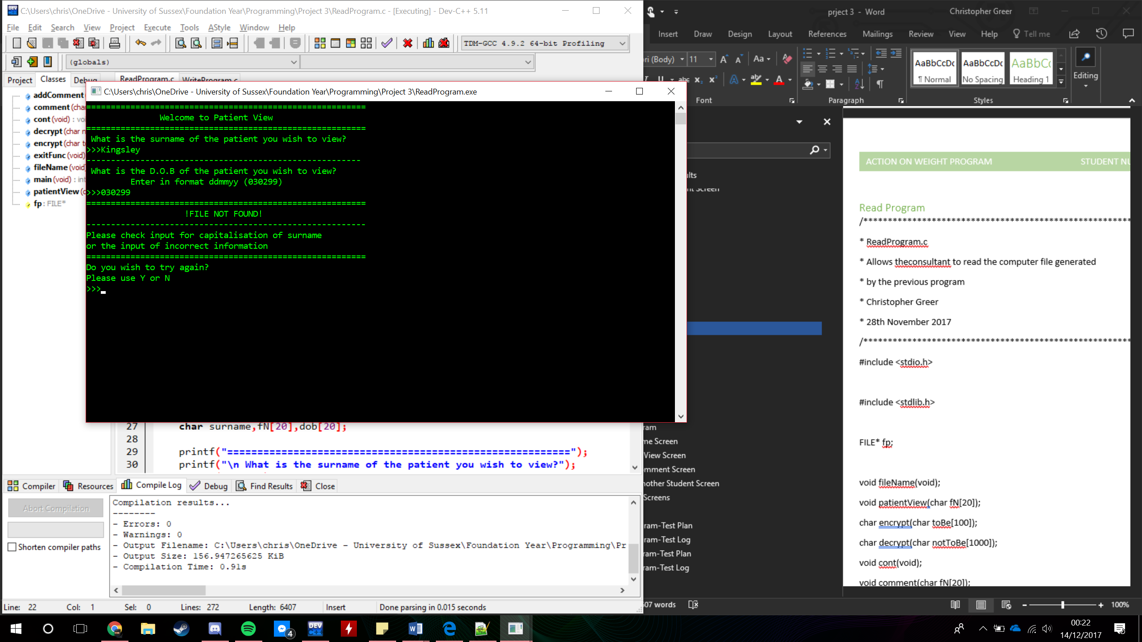This screen is very similar to its design counterpart just with a better layout and overall design

### Patient View Screen

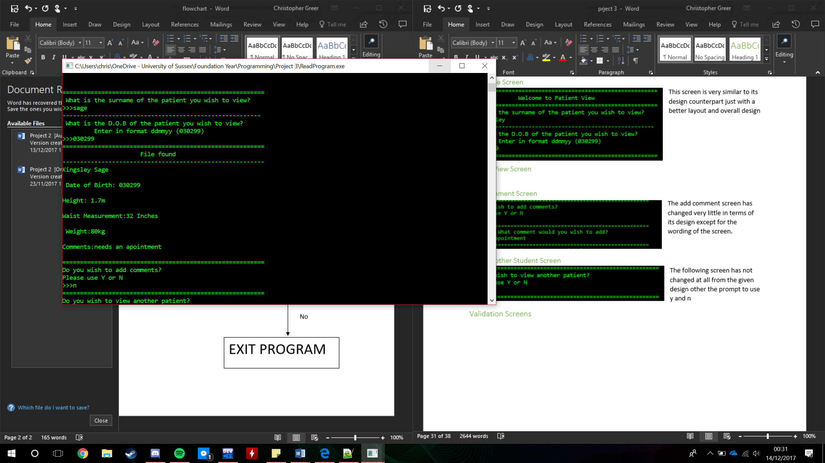The patent view screen is the most important screen of the program as with out it the function would be worthless. From its design it has changed very little other than the banner announcing the file is found and the layout of some of the items. However behind the scene it is one of the more complicated as it must decrypt the given file before printing it.

### Add Comment Screen

The add comment screen has changed very little in terms of its design except for the wording of the screen.

### View Another Student Screen

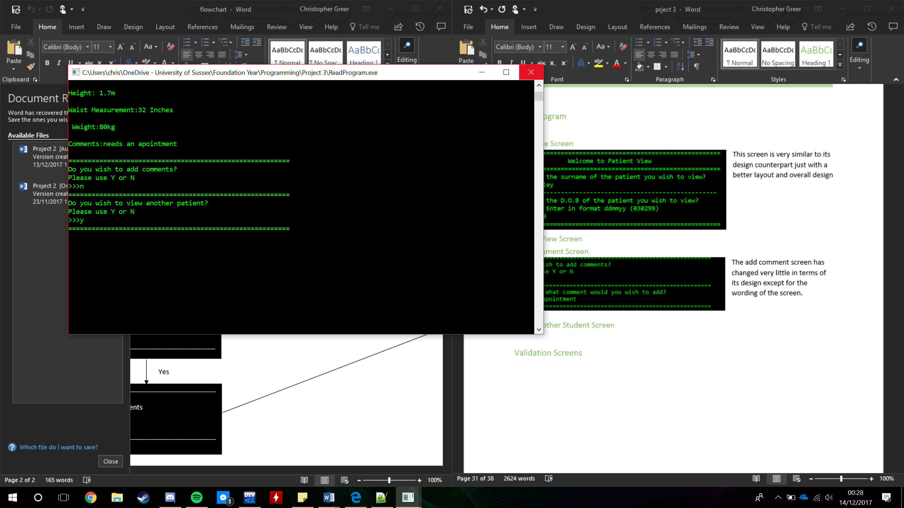The following screen has not changed at all from the given design other the prompt to use y and n

# Testing

The following are testing plans to show what happens in the program when incorrect values are entered into the system and the upper and lower boundaries of the expected inputs. All of the test logs are straight copy and pastes directly from the interface or screenshots of the command window depending on the length of the test at hand.

## Write Program-Test Plan

|  |  |  |  |
| --- | --- | --- | --- |
| Step | Input Data | Expected Output | Comment |
| 1 | theresa  aBc2xyz8  1  Sage  030299  Kingsley  1.7  32  80  Needs an appointment  2 | First Name?  Password?  Option?  Surname of patient?  DOB of patient?  First name of patient?  Height of patient?  Waist of patient?  Weight of patient?  Comments?  Option?  Exiting…….. | Intended inputs when adding a single patient |
| 2 | Hteresa  y  theresa  aBc2xyz8 | First Name?  Password?  Incorrect Username  Would you like to try again?  First Name?  Password?  Main Menu | Incorrect username validation |
| 3 | theresa  Bac2xyz8  Y  theresa  aBc2xyz8 | First Name?  Password?  Incorrect Password  Would you like to try again?  First Name?  Password?  Main Menu | Incorrect password validation |
| 4 | theresa  aBc2xyz8  3 | First Name?  Password?  Option?  Incorrect Option  Option? | Incorrect option validation |

## Write Program-Test Log

|  |  |  |
| --- | --- | --- |
| Step | Actual Output | Comment |
| 1 | =========================================================  Welcome to Patient Entry  =========================================================  What is your first name?  >>>theresa  ---------------------------------------------------------  What is your password?  >>>  =========================================================  Main Menu  ---------------------------------------------------------  What function do you wish to use?  Option 1:Add  Option 2:Exit  >>>1  =========================================================  What is the surname of the patient?  >>>Sage  What is the Date of Birth of the patient?  >>>030299  What is the first name of the patient?  >>>Kingsley  What is the Height of the patient in metres?  >>>1.7  What is the Waist Measurement of the patient?  >>>32  What is the Weight of the patient?  >>>80kg  Are there any comments for the patient?  If not type N/A  >>>needs an appointment  =========================================================  Main Menu  ---------------------------------------------------------  What function do you wish to use?  Option 1:Add  Option 2:Exit  >>>2  =========================================================  Exiting Program…………………..  ========================================================= | Intended use of the program  Works as expected |
| 2 |  | Works as Intented |
| 3 |  |  |
| 4 |  | Works as intended |

## Read Program-Test Plan

|  |  |  |  |
| --- | --- | --- | --- |
| Step | Input Data | Expected Output | Comment |
| 1 | Sage  030299  Y  Needs an appointment  Y | First name: Kingsley  Surname: Sage  Date of Birth: 030299  Height: 1.7m  Waist: 32 inches  Weight: 80kg  Comments: needs an appointment | The intended inputs and outputs for the function selecting all possible options |
| 2 | aSge  030299 | Surname?  DOB?  Incorrect Username or Password | Validation of name |
| 3 | Sage  020399 | Surname?  DOB?  Incorrect Username or Password | Validation of date |
| 4 | Sage  030299  N | Surname?  DOB?  Kingsley Sage  Date of Birth: 030299  Height: 1.7m  Waist Measurement:32 Inches  Weight:80kg  Comments:N/A  New Comments? | No comments |
| 5 | Sage  030299  N  N | Exiting Program…… | Only viewing a single patient, then exiting the program |
| 6 | Sage  030299  Y  Needs an appointment  Y  Sage  030299 | Surname?  DOB?  Kingsley Sage  Date of Birth: 030299  Height: 1.7m  Waist Measurement:32 Inches  Weight:80kg  Comments:N/A  New Comments?  Needs an appointment  Surname?  DOB?  Kingsley Sage  Date of Birth: 030299  Height: 1.7m  Waist Measurement:32 Inches  Weight:80kg  Comments:Needs an appointment  New Comments? | Check that comments are added |

## Read Program-Test Log

|  |  |  |
| --- | --- | --- |
| Step | Actual Output | Comment |
| 1 | =========================================================  Welcome to Patient View  =========================================================  What is the surname of the patient you wish to view?  >>>Sage  --------------------------------------------------------  What is the D.O.B of the patient you wish to view?  Enter in format ddmmyy (030299)  >>>030299  =========================================================  File found  ---------------------------------------------------------  Kingsley Sage  Date of Birth: 030299  Height: 1.7m  Waist Measurement:32 Inches  Weight:80kg  Comments:N/A  =========================================================  Do you wish to add comments?  Please use Y or N  >>>Y  =========================================================  What comment would you wish to add?  >>>Needs an appointment  =========================================================  Do you wish to view another patient?  Please use Y or N  >>>Y  =========================================================  =========================================================  What is the surname of the patient you wish to view?  >>> | Works as intended |
| 2 |  | Gives correct validation due to incorrect name given |
| 3 |  | Gives correct validation due to incorrect date given |
| 4 |  | Comments section correctly bypassed |
| 5 |  | Exits the program but does not display the intended message |
|  | =========================================================  Welcome to Patient View  =========================================================  What is the surname of the patient you wish to view?  >>>Sage  --------------------------------------------------------  What is the D.O.B of the patient you wish to view?  Enter in format ddmmyy (030299)  >>>030299  =========================================================  File found  ---------------------------------------------------------  Kingsley Sage  Date of Birth: 030299  Height: 1.7m  Waist Measurement:32 Inches  Weight:80kg  Comments:N/A  =========================================================  Do you wish to add comments?  Please use Y or N  >>>Y  =========================================================  What comment would you wish to add?  >>>Needs an appointment  =========================================================  Do you wish to view another patient?  Please use Y or N  >>>Y  =========================================================  =========================================================  What is the surname of the patient you wish to view?  >>>Sage  --------------------------------------------------------  What is the D.O.B of the patient you wish to view?  Enter in format ddmmyy (030299)  >>>030299  =========================================================  File found  ---------------------------------------------------------  Kingsley Sage  Date of Birth: 030299  Height: 1.7m  Waist Measurement:32 Inches  Weight:80kg  Comments:Needs and appointment  =========================================================  Do you wish to add comments?  Please use Y or N  >>>Y |  |

# Evaluation

The program adheres completely to the given specification with all of the functions and features working as expected. From testing there seemed to be no problems or bugs that would affect the intended users of the five Nurses and Doctors as they used the program to carry out their tasks. They only bugs testing showed were all layout wise where certain banners were not centred or two lines on patient view were slightly to the side compared to the others. Seeing as these were just slight formatting errors the program will still work. All though the program functions as intended the code is not necessarily to the specification as the encryption function I wrote is does not use the intended characters. This is due to a problem I ran into where certain letters were becoming the same number meaning each number had two possible decryptions. To solve this, I decided to use some symbols for half of these letters to encrypt into and in doing so I managed to fix this issue as files and passwords now encrypt and decrypt without any known issues. In terms of the structure of my code certain functions have multiple features as certain values had trouble passing to their separate functions. Most of these issues were later resolved decreasing the size of the functions, although one such function that had this problem was the encrypt function which was located within the enter password function. This would have meant that I would have had to copy and paste this code into the add function leaving me with two very large functions. Now however these functions are a lot smaller in size making the program much more efficient.

To conclude my function contains all features that are needed for the users to complete their work and for it to be used effectively. Although I had some issues along the way the majority of them have been fixed in some kind of way leaving an efficient program that can solve any required task that fits its specification. Those that have not been fixed are simply formatting issues with the layout of certain screens that have no overall impact on the use or the efficiency of the program.